更新KOL寻找算法之后的发现

## 词频

不变：

* 总体聚焦的三个最重要的问题还是trust, diversity和transparency
* Trust: community support
* Ethic：scam最突出
* Fairness: women, equity
* Diversity: inclusive, artist, metaverse, collection, space

变化：

* Bias: 认证偏误，幸存者偏差
* Trust和Fairness：提到Verifiable random function（VRF）技术
* Diversity：提到了纽约的展览，Diversity of NFT's Art Showcase，很多项目参加，有评选diversity的奖项，点击看👉[名单](https://twitter.com/annadart_artist/status/1530240308646232066)

## Biagram

### Bias group

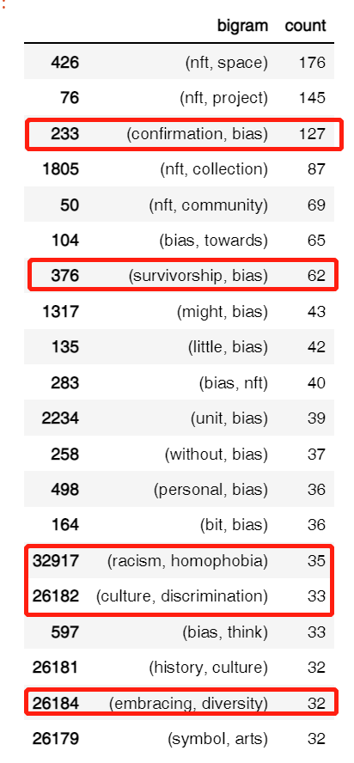

**确认偏误 (Confirmation bias)**

确认偏误是个人选择性地回忆、搜集有利细节，忽略不利或矛盾的资讯，来支持自己已有的想法或假设的趋势，属其中一类认知偏误和归纳推理中的一个系统性错误。当人们选择性收集或回忆信息时，又或带有偏见地解读信息时，他们便展现了确认偏误。

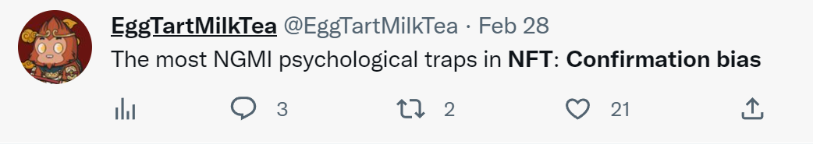

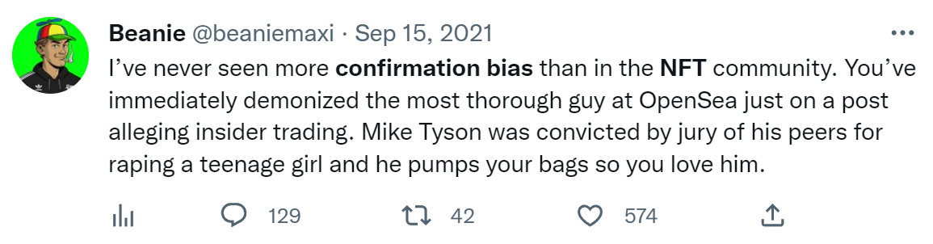

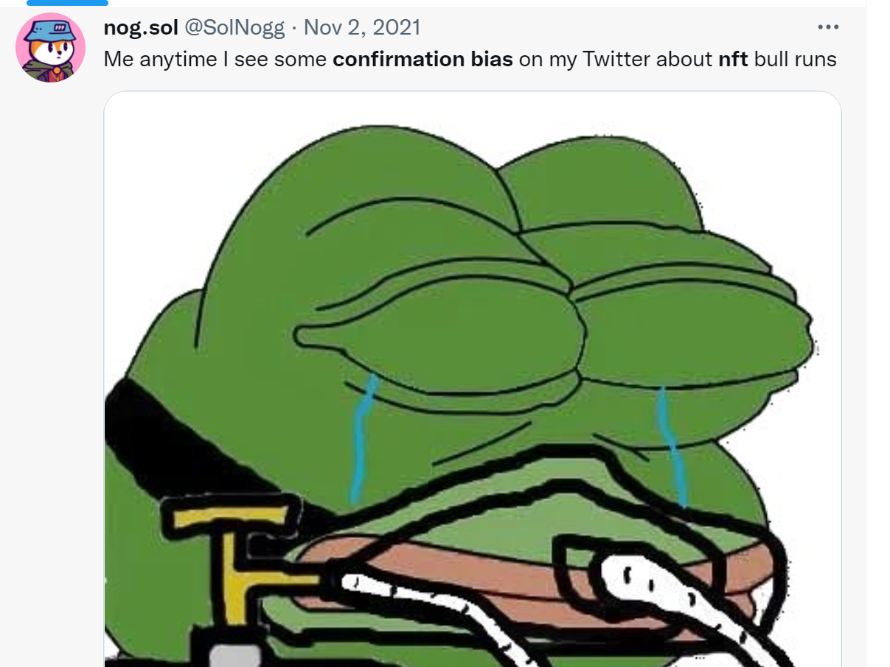

**幸存者偏差 (Survivorship bias)**

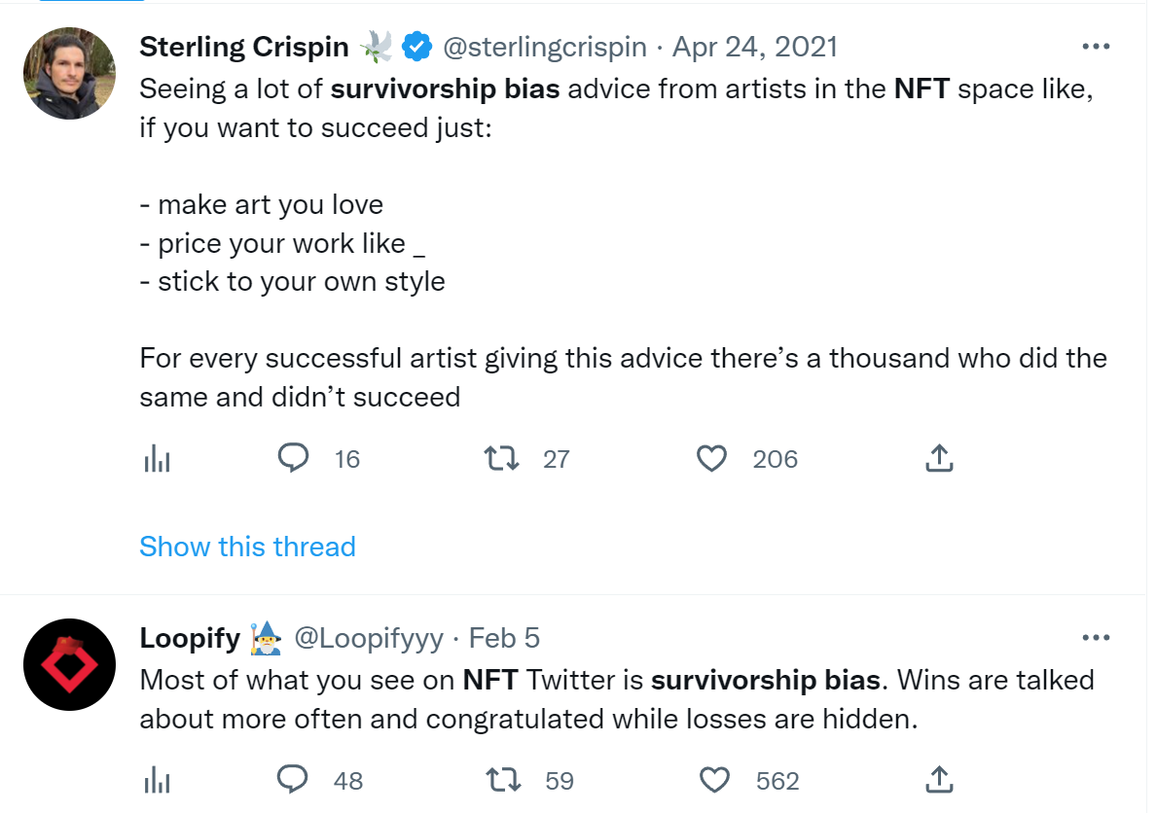

“用爱交织的谎言？”，“买NFT=支持同性恋/多元/包容”

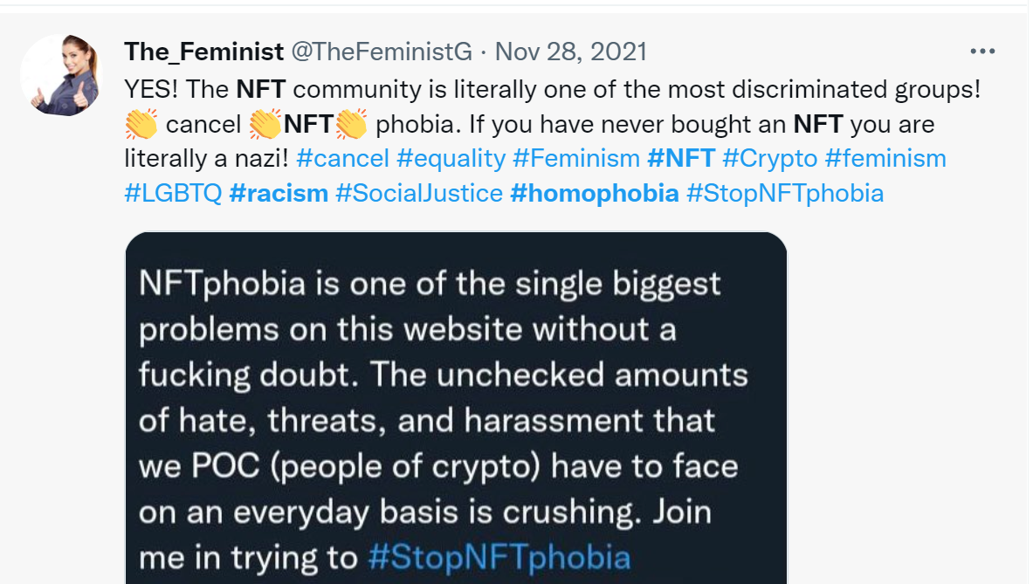

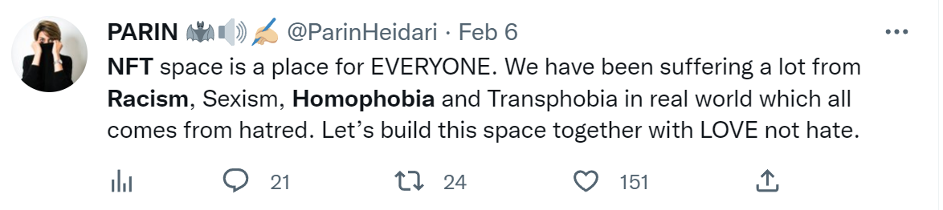

### Fairness group

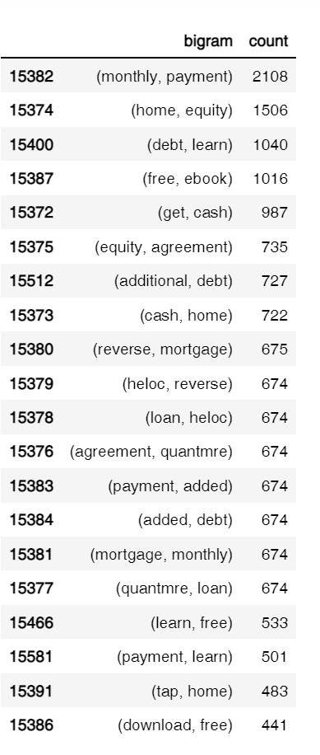一些金融手段，房屋贷款抵押什么的，没看懂

### Trust group

1. 钱包的问题

2. 高度强调项目, 团队的透明和计划

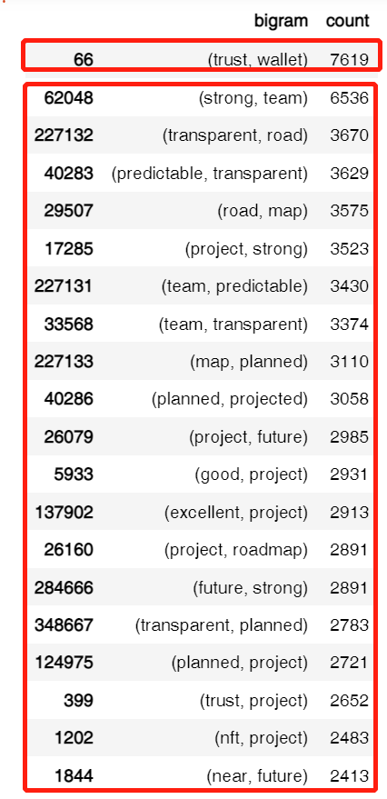

### Ethic group

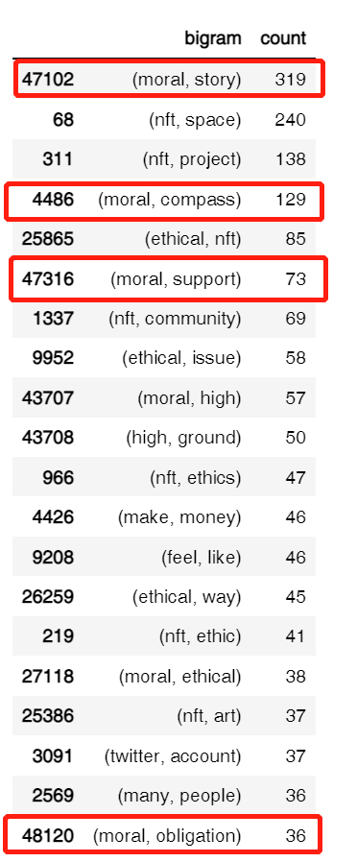

"Moral compass": 赚到钱的人成为了NFT项目道德方向的布道者

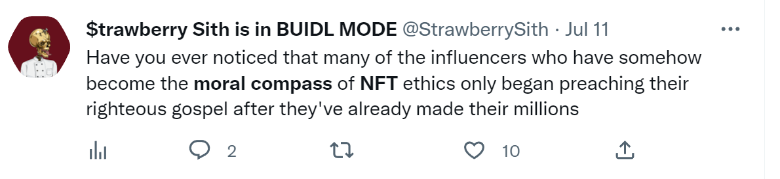

"Moral of the story"：布道习惯，总习惯给推特内容上点价值。

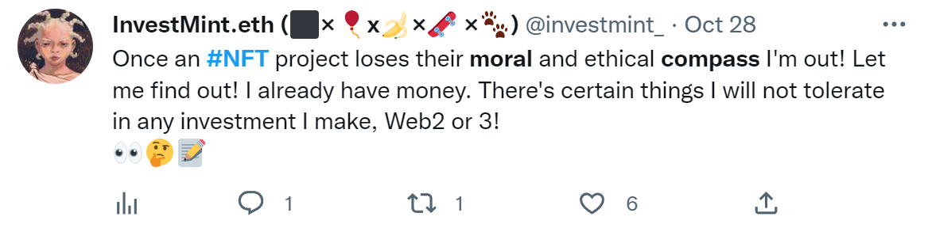

货币化是90%以上NFT空间的道德轮盘，而不是长期视角和道德。

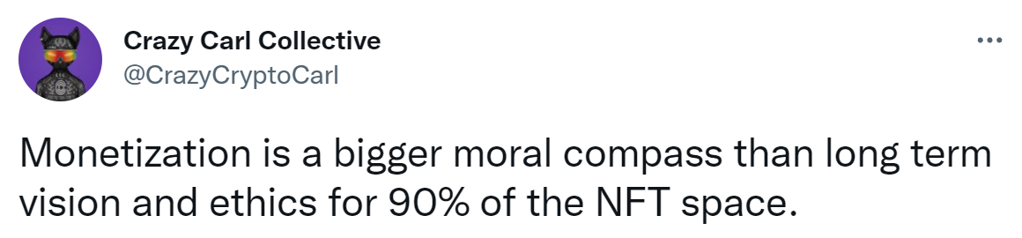

[HYPE AND HYPOCRISY: THE HIGH ETHICAL COST OF NFTS](https://ethics.org.au/hype-and-hypocrisy-the-high-ethical-cost-of-nfts/)

[The Moral Complexity of Ethics in NFTs](<https://www.bueno.art/blog/ethics-nfts>)

### Diversity group

多元：项目本身，艺术家，团队，community

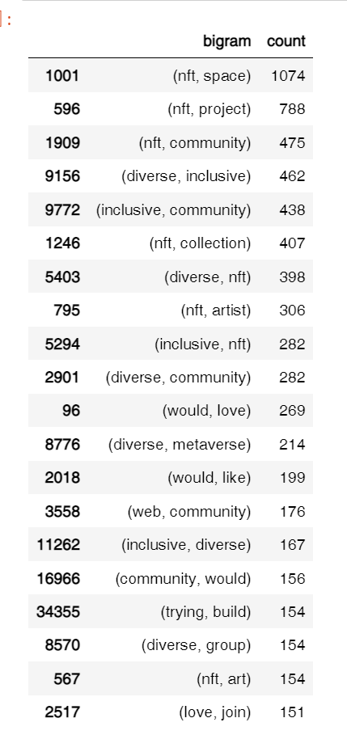

## Network

* 这次diversity的图生成的比较好，可以清晰地看到diverse和inclusive在nft领域中指的是什么。
* Love和join有比较深的连接，结合对推特的定性分析，发现以diversity和爱为名义，是非常多NFT项目品牌宣传和邀请人加入的手段。

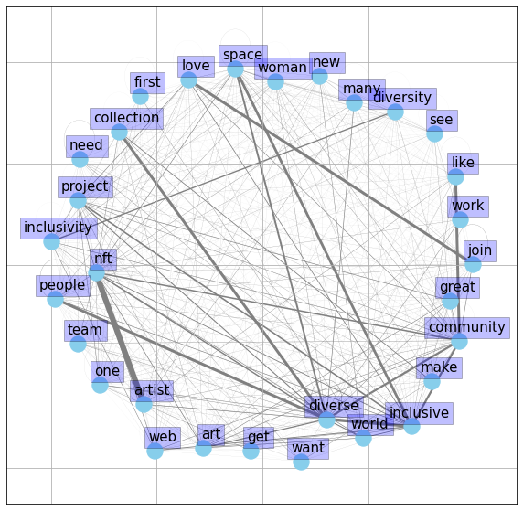

## Topic modelling

### All tweets

|  |  |  |
| --- | --- | --- |
| Topic | Words | **Interpretation** |
| 14 | ['build', 'time', 'want', 'nft', 'world', 'join', 'transparent', 'transparency', 'way', 'community’] | NFT advertising. (Attract to join by being transparent, diverse, inclusive) |
| 10 | ['help', 'nft', 'diverse', 'trying', 'artist', 'join', 'build', 'love', 'web', 'community’] |
| 9 | ['new', 'join', 'inclusive', 'eth', 'drop', 'today', 'metaverse', 'collection', 'nft', 'diverse’] |
| 1 | ['trust', 'artist', 'join', 'drop', 'nft', 'want', 'inclusive', 'world', 'eth', 'make'] |
| 0 | ['inclusive', 'eth', 'time', 'today', 'artist', 'want', 'think', 'account', 'mint', 'know'] | NFT work and Artists (transparency, trust, inclusive and trust) |
| 12 | ['thing', 'artist', 'transparency', 'trust', 'work', 'project', 'want', 'think', 'nft', 'like'] |
| 4 | ['artist', 'think', 'want', 'space', 'mint', 'project', 'nft', 'need', 'new', 'transparency'] |
| 2 | ['community', 'think', 'make', 'want', 'work', 'artist', 'inclusive', 'good', 'nft', 'space'] |
| 6 | ['want', 'nft', 'work', 'inclusive', 'artist', 'time', 'trust', 'team', 'help', 'support'] | Expectation on NFT (inclusive work and artist, helpful team) |
| 3 | ['project', 'good', 'build', 'drop', 'nft', 'artist', 'think', 'want', 'work', 'trust'] |
| 13 | ['project', 'space', 'community', 'think', 'today', 'collection', 'artist', 'art', 'trust', 'nft'] | NFT stakeholders (specified to project, collection, artist, community and trust) |
| 8 | ['thing', 'web', 'trust', 'good', 'time', 'nft', 'space', 'think', 'want', 'people'] | Discussion about good NFT collection metrics (trust, time. team, transparency) |
| 7 | ['good', 'people', 'eth', 'time', 'drop', 'project', 'want', 'trust', 'day', 'lot'] |
| 5 | ['today', 'good', 'collection', 'think', 'nft', 'eth', 'trust', 'love', 'thing', 'time'] |
| 10 | ['build', 'time', 'art', 'want', 'good', 'team', 'think', 'nft', 'transparent', 'project'] |

### KOL

|  |  |  |
| --- | --- | --- |
| Topic | Words | **Interpretation** |
| 0 | ['today', 'eth', 'good', 'like', 'work', 'mint', 'artist', 'account', 'art', 'know'] | Discussion about ETH, minting, artists and art |
| 1 | ['need', 'thing', 'people', 'inclusive', 'world', 'eth', 'nft', 'transparent', 'like', 'make'] | People need on NFT world (inclusive, transparent) |
| 3 | ['time', 'need', 'good', 'eth', 'art', 'like', 'transparency', 'work', 'nft', 'trust'] | Requirements on good NFT project (art, eth, mint, inclusive, transparency, trust) |
| 4 | ['art', 'inclusive', 'transparent', 'community', 'mint', 'transparency', 'new', 'nft', 'need', 'project'] |
| 5 | ['project', 'transparency', 'lot', 'nft', 'transparent', 'team', 'thing', 'good', 'think', 'time'] | About trust and transparency of NFT project (people, team, community and support) |
| 7 | ['people', 'world', 'thing', 'eth', 'transparency', 'day', 'love', 'trust', 'lot', 'way'] |
| 6 | ['mint', 'time', 'nft', 'transparent', 'new', 'help', 'trust', 'team', 'want', 'support'] |
| 2 | ['like', 'artist', 'trying', 'diverse', 'nft', 'join', 'build', 'love', 'web', 'community'] | About diversity and inclusivity of NFT space (community, love, people and collection) |
| 8 | ['diverse', 'want', 'lot', 'good', 'like', 'new', 'inclusive', 'nft', 'space', 'people'] |
| 9 | ['mint', 'join', 'eth', 'inclusive', 'today', 'drop', 'metaverse', 'collection', 'nft', 'diverse'] |